[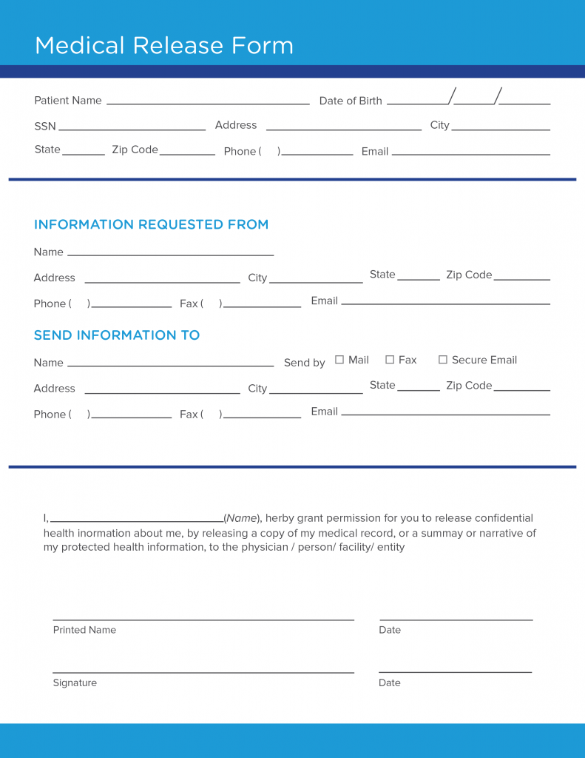](https://www.carecloud.com/continuum/wp-content/uploads/2019/03/medical_release_form_template-min.png)